SHADOW REPORT TO THE COMMITTEE ON THE CONVENTION ON THE ELIMINATION OF ALL FORMS OF DISCRIMINATION AGAINST WOMEN (CEDAW)

SUBMITTED By
The Rwanda National Association of Deaf Women( RNADW “Umucyo”)
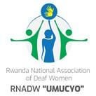
Hope for Single Mothers with Disabilities (HSMD)
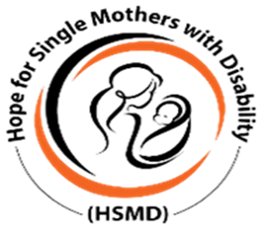

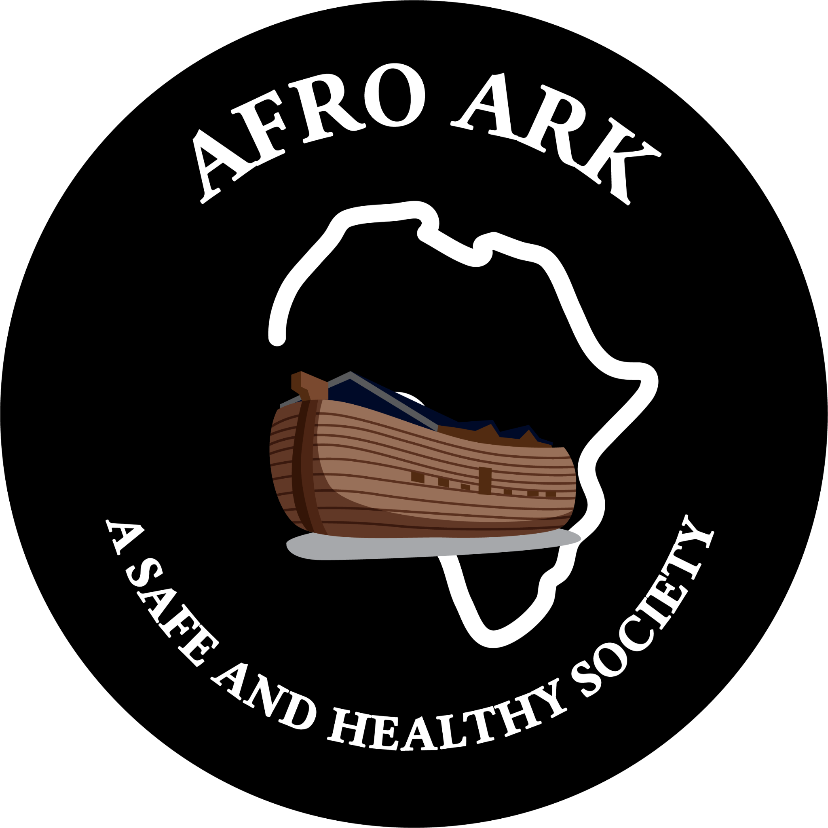
Afro Ark

April 2024
Table of Contents

ABOUT CONSORTIUM 3
EXECUTIVE SUMMARY 4
Objective of the Report 4
Methodology 4
Key Findings 4
POLITICAL AND PUBLIC LIFE (Article 7(b) of CEDAW) 5
Recommendation 7
HEALTHCARE AND FAMILY PLANNING (Article 12 of CEDAW) 8
Recommendation: 9
REFERENCES .
A. Laws and conventions 11
B. Policies and Strategies 11
C. Reports and Surveys 11

ABOUT CONSORTIUM

Rwanda National Association of Deaf Women (RNADW “Umucyo”) is a non-profit organization that aims to empower and advocate for the rights of deaf women in Rwanda. Through various programs and initiatives, the organization provides support to deaf women in areas such as education, employment, and healthcare. The organization also works to raise awareness about the challenges faced by deaf women in Rwanda and to promote inclusion and equality.
Hope for Single Mothers with Disabilities (HSMD) is another non-profit organization that focuses on supporting single mothers with disabilities in Rwanda. The organization provides various services such as financial assistance, vocational training, and counseling to help these women become self-sufficient and independent. Additionally, the organization works to break down the stigma surrounding disability and single motherhood in Rwanda.
Afro Ark is a dynamic and visionary non-governmental organization led by young women who are determined to create a world where gender equality through Empowerment of women and girls of diverse backgrounds and vulnerabilities. Afro Ark's ultimate goal is to eliminate malnutrition, poverty, and preventable diseases, and to empower women and girls to fully participate in all aspects of society.
Afro Ark is committed to advocating for and building the capacity of vulnerable populations in Rwanda and across Africa. Its mission is to empower women and girls through capacity building and advocacy on health, leadership, education and economic strengthening in Rwanda and across Africa.
From their inception, these three organizations have been actively involved in the realm of human rights, with a particular focus on the rights of women and girls, especially those with disabilities. Their initiatives aim to promote gender equality and empower women and girls, while also encouraging men to embrace positive masculinity and engage in the fight for human, women's, and child rights.
Ultimately, these organizations share a common goal of empowering marginalized groups in Rwanda and promoting a culture of equality and inclusion.

EXECUTIVE SUMMARY

The Consortium takes this opportunity to submit a shadow report in parallel to the 10th CEDAW report of the Government of Rwanda, to the Committee on the Elimination of Discrimination Against Women (CEDAW Committee).

Objective of the Report

The purpose of this report is to present significant findings regarding the implementation of The Convention on the Elimination of All Forms of Discrimination against Women (CEDAW) and its impact on the healthcare and political participation of women and girls with disabilities in Rwanda. Our aim is to provide valuable insights that can help shape legal reforms, policy changes, and other measures that will enhance the rights of women and girls with disabilities in Rwanda, especially in terms of their healthcare including, Sexual and Gender Based Violence (SGBV) and political life in reference to CEDAW article 7 , “ States Parties shall take all appropriate measures to eliminate discrimination against women in the political and public life of the country and, in particular, shall ensure to women, on equal terms with men, the right to participate in the formulation of government policy and the implementation thereof and to hold public office and perform all public functions at all levels of government” and article 12 “States Parties shall take all appropriate measures to eliminate discrimination against women in the field of health care in order to ensure, on a basis of equality of men and women, access to health care services, including those related to family planning and to ensure to women appropriate services in connection with pregnancy, confinement and the postnatal period, granting free services where necessary, as well as adequate nutrition during pregnancy and lactation.”

Methodology

The drafting of this report was based on data collected from studies, national reports, interviews with key informants (public, private institutions and Civil Society Organizations (CSOs) especially those intervening in the disability domain), national documents including; laws, policies and strategic plans.

Key Findings

The report notes progress made by the Government of Rwanda in implementing recommendations contained in previous reports and observations. The report notes with appreciation, legal and policy reforms undertaken as well the adoption of various policies, strategic plans and initiatives which have contributed to the improvement of women and girls with disabilities’ rights in Rwanda.

POLITICAL AND PUBLIC LIFE (Article 7(b) of CEDAW)

The Government of Rwanda has made tremendous efforts in reducing inequality and guarantees the principle of equality of all citizens, and this protection is embedded into the 2015 revised Constitution of Rwanda. Discrimination of any nature is prohibited in the same Constitution and the government has further enacted other laws, policies, strategies and programs that ensure realization of equal protection before the laws. By ratifying different international human rights instruments that protect the rights of persons with disability including the Convention on the Rights of Persons with Disabilities and the AU Protocol to the African Charter on Human and Peoples’ Rights on the Rights of Persons with Disabilities in Africa. We equally reiterate the acknowledgement of progress made by the UN committee on the Rights of Persons with Disabilities in their 2019 review of Rwanda, notably “the enactment of legislation prohibiting any form of discrimination based, inter alia, on disability, adoption of article 163 of the Rwanda Penal Code, which was published on 27 September 2018, the adoption of Law No. 03/2011 determining the responsibilities, organization and functioning of the National Council of Persons with Disabilities, and the ministerial orders of 2009 relating to measures to facilitate communication, travel, education, sports and leisure, medical care and employment for persons with disabilities and the commitment made by the State party during the Global on Disability Summit, held in London on 24 July 2018”. We also note with appreciation, progress made to adopt the national disability policy, in 2021 and the ongoing process to adopt the Rwanda sign language dictionary. This demonstrates the government’s commitment towards legitimizing the rights of Persons with Disabilities (PWDs).
Despite efforts to better address the representation of both women and PWDs in the political sphere, Women with Disabilities (WWD) remain largely under-represented in political spheres including in government institutions. Rwanda has a strong women’s representation with 61% of women sitting at the Chamber of Deputies; exceeding the minimum 30% rule. However, only one in 80 seats is reserved for persons with disabilities. Rwanda is ranked among the top six countries for being the champions of gender equality promotion. However, there is no specific representation of women with disabilities in the parliament (Chamber of Deputies, Senate and in East African Legislative Assembly - EALA) as well in other public and private decision-making positions including mainstream women and youth councils.
There is a challenge of disaggregated data at decentralized levels of political governance, in relation to WWDs. However, at known provincial, districts, sectors, cells and village levels, WWDs are less represented if at all. At national committees for PWDs, only 3 out of 30 districts in Rwanda have women as district coordinators.
Women with disabilities in all their diversity are excluded and do not enjoy this outstanding fete of general women political representation . Their political representation remains theoretical in principle. UNABU (Rwandan Organization of Women with Disabilities) report submitted to the CEDAW committee in 2023, revealed that the reserved seat, elected by the National Council of Persons with Disabilities (NCPD), has been permanently occupied by a man.
From different stakeholders, it has come to light that there is an issue with the utilization of a seat specifically reserved for persons with disabilities. Rather than serving its intended purpose of providing equal opportunity, it is being used as a tool to prevent persons with disabilities from pursuing different political positions, including the 30% quota for women. Women with disabilities who express interest in running for these positions are being told to hold on and wait for the reserved seat. Surprisingly, this seat has never been occupied by a woman since its implementation. This is not only unfair but also goes against the very essence of inclusion and diversity that we strive for.
One of the most significant historical factors contributing to these obstacles is cultural factors to the participation of Women Girls with Disabilities (WGWDs) in public life. In Rwanda, traditional gender roles and expectations limit women's participation in politics and public life. Many women are expected to focus on domestic duties and child-rearing and are discouraged from pursuing careers in politics and other public roles, and these cultural factors have created multiple and intersecting discriminations and marginalizations for WGWDs .
Socio-economic factors contribute to the obstacles faced by WGWDs in Rwanda including social cultural based stigma, poverty and inaccessibility to academic institutions that meet the needs and accessibility for various disabilities for WGWDs. Many women are unable to access education and job opportunities, making it difficult for them to develop the skills, live decent and dignified livelihoods and experience necessary to participate in public life. This can limit their ability to gain the confidence and support necessary to run for public office or participate in policy-making processes.
Additionally, women with disabilities are not represented in other specific women-specific forums including the National Women’s Council. This leads to limited participation in decision making processes for women with disability at both local, community and national levels.
Women with disabilities are severely underrepresented in decision making at different levels. Evidence from the 2017 UN Women report illustrates that only 2.3% of women with disabilities held positions as senior officials or managers and in Rwanda it is hardly reported that a woman or female youth with disability occupies a legislative position in a national legislative body.
Women with disabilities in Rwanda are underrepresented in national coordination mechanisms for PWDs. This has been witnessed in areas where men are overrepresented instead in most institutions making almost 43% of men representation in these coordination mechanisms compared to 24% of women with disability in the stated coordinated areas.
In most low and high leadership positions from the national, mid-level and community level, women with disabilities are not represented in the forums that take decisions more especially on issues that touch the lives relevant to persons with disabilities including access to health care among other rights. This disproportionately affects women and female youth with disabilities, who are diverse with diverse needs.

Recommendations

The in relation to CEDAW article 7, the consortium calls upon the CEDAW Committee to recommend the Government of Rwanda to:

- Ensure that women with disabilities participate in the formulation of government policies and implementation thereof and to hold public office and perform all public functions at all levels of Government;
- Ensure women and girls with disabilities are included into 30% quota of women in parliament and other decision making positions at all levels;
- Repeal restrictions to be elected and to vote in the article 8 (3) and 24 (4) of Organic Law of 2019 Governing elections, which deny persons with intellectual or psychosocial disabilities their rights to vote and to run for election;
- Adopt a plan to ensure the accessibility of voting procedures, facilities,and materials, including through the provision of electoral materials and information,in accessible formats for all persons with disabilities;
- Take all appropriate measures, including specific measures, to ensure,the participation of persons with disabilities, especially women with disabilities, in political life and public decision-making, including in the Parliament, the Government,mainstream women’s organizations and the leadership of the National Council of Persons with Disabilities
- The Government of Rwanda should implement capacity building and sensitization engagements to the electoral officials to understand the needs of the persons with disability especially women to ensure that they are fully represented;
- Ensure promotion of civic and voter education, encouraging general electoral awareness on the civil and political rights of persons with disability;
- Support technical assistance to electoral stakeholders on promoting and facilitating inclusive electoral arrangements and participation of persons with disability especially women.
- Allocate sufficient and sustained financing for the implementation of the National Disability policy with a gender responsive approach.
- Recognize Rwandan sign language as an official language, expedite the
completion of the Rwanda sign language dictionary, once adopted, put into place financing for training, standardization and certification for sign language interpretation and
ensure that sign language interpretation services are available to persons who are deaf;

HEALTHCARE AND FAMILY PLANNING (Article 12 of CEDAW)

Women and Girls with disabilities in all their diversity have the same Sexual and Reproductive Health (SRH)-related needs and rights as those without disabilities. Studies have shown that they are sexually active and have the same concerns about sexuality, relationships, and identity as their peers. Yet too often stigma and misconceptions about disability, along with a lack of accessible SRH information and services, limited personal autonomy, and a lack of empowerment, prevent women and girls with disabilities from leading healthy sexual lives and fully enjoying their rights.
The inability of Women and Girls with disabilities to access health services is due to a complex web of structural and systemic discrimination made up of negative social attitudes and cultural assumptions as well as environmental barriers including policies, laws, structures and services which results in marginalization and social exclusion.
Furthermore, SRHR service providers and other key stakeholders often fail to provide information to women including young girls with disabilities due to stereotypical beliefs that persons with disabilities are asexual, uninterested, or incapable of consenting.
Women and girls with disabilities (WGWDs) in Rwanda face numerous obstacles when trying to access healthcare information and services. These include physical and geographical barriers, financial limitations, discrimination, and lack of accessible medical equipment or facilities.
One of the main challenges WGWDs face is physical and geographical barriers. Many health facilities in Rwanda are not equipped to accommodate people with disabilities, which makes it difficult for WGWDs to access healthcare services. Additionally, many health facilities are located in areas that are difficult to reach, particularly for those with mobility challenges.
Another significant challenge is financial limitations, as some WGWDs may struggle to afford healthcare services or may not have access to health insurance. This can make it difficult for them to access needed medical care, including treatment and medication.
Discrimination against WGWDs also remains a challenge in Rwanda. This includes discrimination within healthcare settings, as some health workers may not fully understand the needs of WGWDs or may be limited in their ability to provide appropriate care.
Negative attitudes of healthcare providers emerged as a major barrier for WWDs accessing SRH services. This manifested in mistreatment at healthcare facilities, including the use of abusive language. These negative attitudes often stem from the assumption that WWDs are asexual, particularly women who are not expected to be pregnant. This not only creates a hostile environment but also discourages WWDs from seeking essential healthcare, potentially leading to poorer sexual and reproductive health outcomes.
There is also a lack of accessible medical equipment and facilities in Rwanda. Many health facilities do not have equipment like wheelchairs, crutches or ramps, which can make it impossible for WGWDs to access care or use the facilities. As a result, some WGWDs may have to rely on family members or caregivers to provide basic care and support, which can limit their autonomy and access to healthcare.
Specific healthcare needs or services are not currently available or accessible to WGWDs in Rwanda. Health facilities may also lack appropriate communication tools, such as sign language interpreters and Braille materials, which can limit access to information about healthcare services and the treatment options available.
We reiterate the UNCRPD concluding observation of 2019 review that there remains a concern that persons with disabilities cannot effectively, participate in the judicial system, especially persons who are deaf and persons with, intellectual or psychosocial disabilities due to lack of knowledge about disability rights within the judicial sector, including among court staff, judges, prosecutors, magistrates, lawyers, law enforcement officials and staff of corrective facilities; the lack of accessibility of judicial premises and proceedings, especially to women and girls with disabilities, and the absence of procedural accommodation.
In 2020, the assessment conducted by National Union of Disability Organizations of Rwanda (NUDOR) in Nyamasheke and Rutsiro districts has shed light on the alarming lack of inclusiveness in health services for PWDs. The research has revealed that women and girls with disabilities face numerous challenges in accessing various services. In fact, only 15.7% of health services in Nyamasheke district are partially physically accessible.

Recommendation:

In relation to CEDAW article 12, the consortium calls upon the CEDAW Committee to recommend the Government of Rwanda to:
- Ensure that women and girls with disabilities, including through economic support and inclusive social protection, receive equitable and accessible information and services, with full consent, on sexual and reproductive healthcare without stigma and discrimination;
- Ensure that women and girls with disabilities are protected from sexual and gender-based violence (SGBV) and are provided with rehabilitation, psychosocial support and access to justice and judicial systems.
- Adopt measures to ensure that all persons with disabilities, especially persons who are deaf and persons with intellectual or psychosocial disabilities, can exercise their right to access to justice. In particular, provide continuous training for those working in the justice and law and order sector on the rights of persons with disabilities, taking into account the diversity of persons with disabilities in judicial proceedings as witnesses, victims or perpetrators;
- Ensure the accessibility of judicial premises and proceedings to all persons with disabilities, especially women and girls with disabilities, by, inter alia, providing accessible and free legal services to persons with disabilities, sign language,interpretation, and comprehensive age- and gender-appropriate procedural accommodation.
- Ensure the sexual and reproductive health rights of women with disabilities are guaranteed, and women with disabilities have the right to bodily autonomy, retain and control their fertility; and are not sterilized without their consent;
- Adopt the legislative and other measures necessary to protect the integrity of persons with disabilities in all settings, including institutional settings in which persons with psychosocial disabilities are still placed, and to prevent and stop forced treatment and forced sterilization of persons with disabilities, particularly those with psychosocial disabilities and women and girls with disabilities.
- Ensure an effective implementation of disability inclusive Gender provisions integrated in policies, legislation, plans, programs, budgets and activities in health that affect women and girls with disabilities;
- Ensure the services at Isange One Stop Centers are fully accessible for women and girls with disabilities;
- Review of the Law N° 21/2016 of 20/05/2016 relating to human reproductive health to Address Needs of Persons with Disabilities (PwDs) and integrate specific needs and issues for WWDs in the next National Strategy on Persons with Disabilities.
- Amend Ministerial Order No. 002/MoH/2019 to ensure personal autonomy, consent and address needs of women with disabilities seeking abortion;
- Ensure that Healthcare providers are equipped to deliver respectful and inclusive care that recognizes sexual and reproductive health needs to all individuals, regardless of disability; including through training service providers on sign language.
- Develop and adopt a new Rwandan Health Sector Strategic Plan that comprehensively integrates the specific healthcare needs and priorities of Women and Girls with Disabilities in all their diversity (WGWDs);
- Integrate a dedicated course on disability care within the healthcare education curriculum;
- Increase awareness campaigns on sexual and reproductive health among women and Girls with disabilities with accessible communication tools;
- Allocate sufficient and sustained financing for the needs of women and girls with disabilities to access a full spectrum of healthcare services.

REFERENCES
- Laws and conventions
- The Constitution of the Republic of Rwanda
- Law N° 21/05/2016 relating to human reproductive rights.
- Law Nº 68/2018 determining offences and penalties in general.
- Law N°59/2008 of 10/09/2008 on prevention and punishment of gender- based violence.
- Law N°10/2013/0L of 11/07/2013 governing Political Organizations and Politicians.
- Organic law n° 001/2019.ol of 29/07/2019 governing elections.
- Law n° 01/2007 of 20/01/2007 relating to protection of disabled persons in general
- Law nº 22/2019 of 29/07/2019 governing the city of Kigali.
- Convention on the Elimination of all forms of Discrimination against Women, (CEDAW)
- United Nations Convention on the Rights of Persons with Disabilities (UNCRPD)
- Law n°03/2011 of 10/02/2011 determining the responsibilities, organization and functioning of the national council of persons with disabilities.
- The African Charter of Human and Peoples Rights (ACHPR), as well as the Protocol to the African Charter on Human and Peoples' Rights on the Rights of Women in Africa (Maputo Protocol).
- Ministerial order n°002/moh/2019 of 08/04/2019 determining conditions to be satisfied for a medical doctor to perform an abortion
- Africa disability Protocol to the African charter on human and peoples’ rights on the rights of persons with disabilities in Africa as ratified by the GvR of Rwanda on 07th September 2020.
- Policies and Strategies
- Ministry of Gender and Family Promotion, The National Policy against Gender Based Violence (2011).
- Ministry of Gender and Family Promotion, The National Strategic Plan for Fighting Against Gender Based Violence (2011-2016)
- Ministry of Gender and Family Promotion, Revised National Gender Policy (2021).
- Fourth health sector strategic plan (2018-2024) Health sector policy (2015)
C. Reports and Surveys
- National Gender Statistics Report (2021)
- WHO-Global report on health equity for persons with disabilities (2022)
- Haguruka Shadow report on women’s participation in political and decision –making processes in Rwanda (2022)
- Tenth periodic report submitted by Rwanda under article 18 of the Convention on the Elimination of All Forms of Discrimination against Women, 2021
- Monitoring Human Rights Experiences of Children and Youth with Disabilities in Rwanda. April, 2021
- https://www.iwraw-ap.org/resources/wgg-gr40-submission/?sf_data=all&_sft_resource_theme=wwd accessed March ,2024.
- Assessment Report on Inclusiveness and Accessibility of Health, Education and Livelihood Services in Nyamasheke and Rutsiro Districts. NUDOR, 2020.

UNABU CEDAW submission to CEDAW “General discussion on equal and inclusive representation in decision making systems”-2023

